Project Development Phase
Model Performance Test

Date | 10 February 2025
Team ID | PNT2022TMIDxxxxxx
Project Name | Script-Controlled ACL – Restrict Record Access Based on Field Value
Maximum Marks

Model Performance Testing:
Project team shall fill the following information in model performance testing template.
S.No. | Parameter | Screenshot / Values
 | Data Rendered | Institution Details list (u_institution_details) rendered in ServiceNow with records for Branch EEE, ECE and CSE (Admin view).  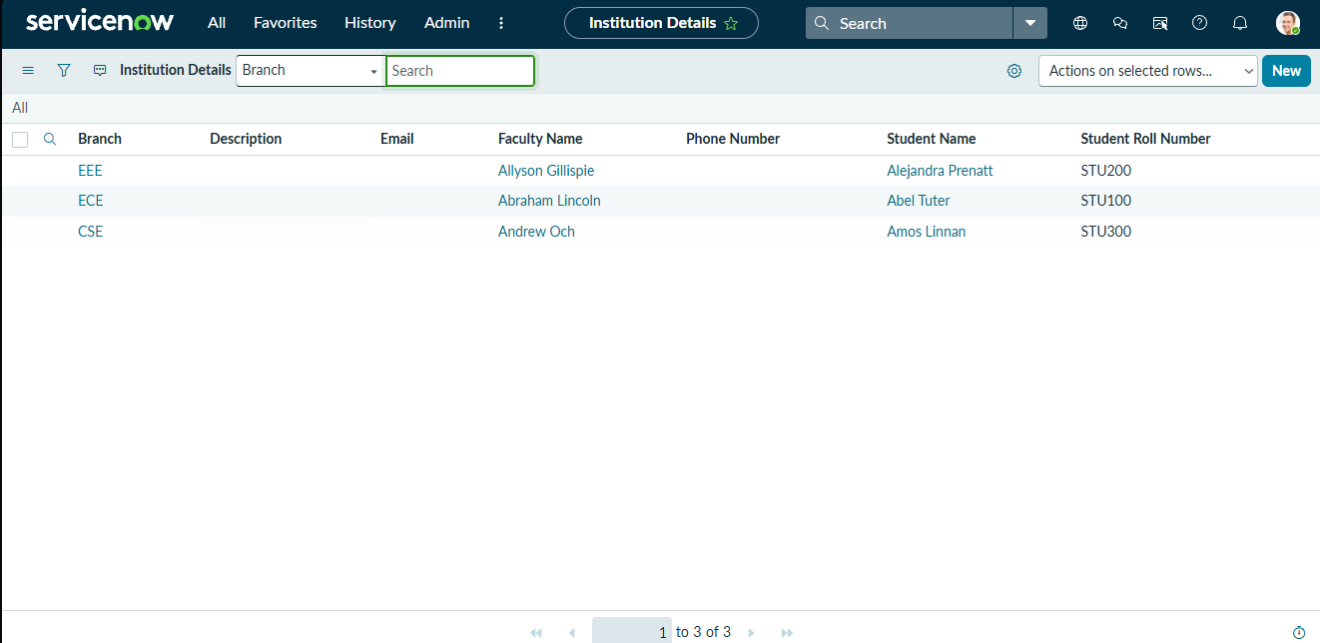
 | Data Preprocessing | Custom table Institution Details (u_institution_details) created with fields Student Roll Number, Student Name, Faculty Name, Branch (ECE, EEE, CSE), Email, Phone Number and Description; EEE User and roles bb1–bb4 created.  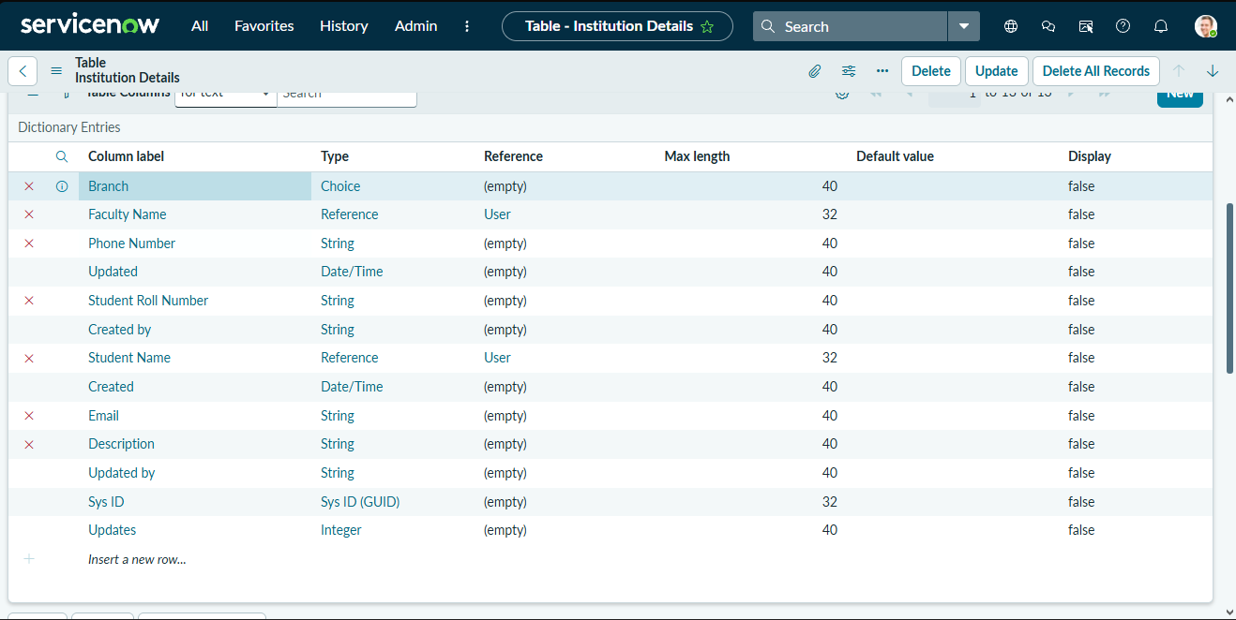
3. | Utilization of Data Filters | Data condition “Branch is EEE” applied on the Read ACL, so users with the bb1 role see only EEE branch records; Admin sees all records.  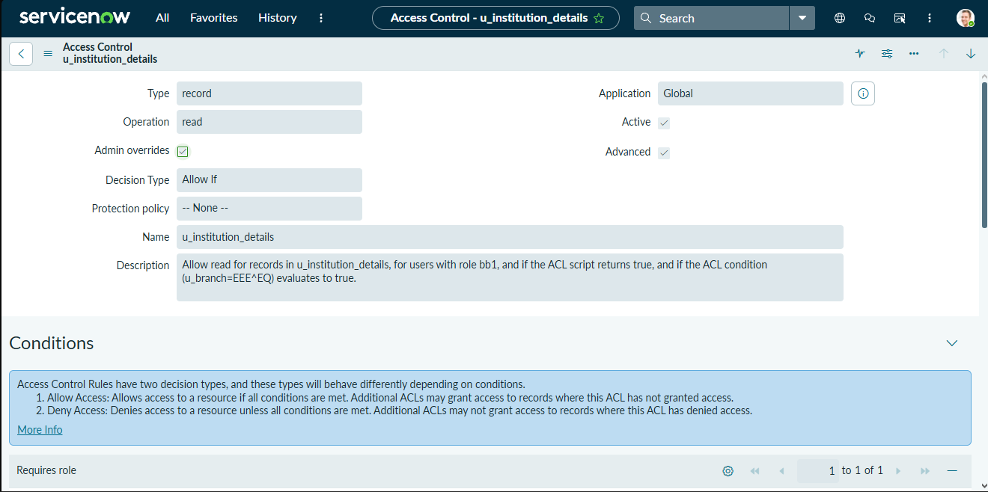
4. | DAX Queries Used | Not applicable – no DAX queries are used. Equivalent logic is written as an ACL script: gs.hasRole('admin') → true; gs.hasRole('bb1') → true; all others → false.
5. | Dashboard design | No of Visualizations / Graphs - 0 (Not applicable – records are presented through the ServiceNow list view of u_institution_details, not a dashboard)
6 | Report Design | No of Visualizations / Graphs - 0 (Not applicable – no Power BI report is used; the final record-access result is shown in the list view)

